 | 26.9.9 Editors - Properties Editor - Modifiers Properties Tab - Volume - Modifiers
Table of content
Detailed table of content 1
Volume - Generate modifiers 2
Geometry Nodes 2
Mesh to Volume 3
Volume - Deform modifiers 3
Volume Displace 4

Detailed table of content
Detailed table of content
Detailed table of content 1
Volume - Generate modifiers 2
Geometry Nodes 2
Data Browser 2
Edit box 2
Add Fake User 2
User 2
Add 2
Remove 2
Mesh to Volume 3
Object 3
Density 3
Fill Volume 3
Exterior Band Width 3
Interior Band Width 3
Resolution Mode 3
Voxel Amount 3
Voxel Size 3
Volume - Deform modifiers 3
Volume Displace 4
Texture Prop 4
Texture Browser 4
Edit Box 4
Change Context 4
Unlink 4
File selector menu 4
New 4
Duplicate 4
Unlink 5
Add Fake User 5
User 5
Texture Mapping 5
Strength 5
Sample Radius 5
Mid Level X Y Z 5

Volume - Generate modifiers

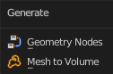

Geometry Nodes
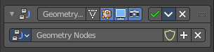
The geometry modifier adds a geometry node tree, which can be modified in the geometry node editor.
Manage the nodes. If there is no geometry node tree for the current object, then you will see the New button

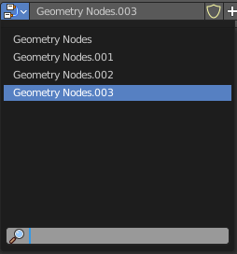
Data Browser
The list of available geometry node trees in the scene.

Edit box
The name of the current active geometry node tree. Here you can also rename the node tree.

Add Fake User
Wit this button you assign a fake user to this selected geometry node tree.
Data, like node trees, that is not longer linked to anything else gets removed when you save and reload a scene. Bforartists has the concept of fake users to go around this behavior. An image with a fake user is in fact linked to something. And so it is not lost when you save and reload the scene.

User
The number of users that uses this data. Data with a user number of 0 will be removed with closing Bforartists.

Add
Add a geometry node.

Remove
Removes the geometry node tree. To delete it completely you need to purge it. See Fake user.

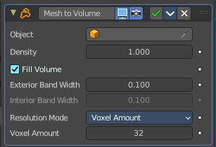
Mesh to Volume
You need a volume object.
The Mesh to Volume modifier uses a mesh to create a new volume grid. All previously existing volume grids on the volume object are discarded. So this modifier is usually added to an empty volume object. The new volume grid is called “density”.
Tip! To copy and move the generated volume separately from the mesh object, use a collection instance.

Object
The mesh object to use for the volume generation. Pick a mesh object here.

Density
Makes the generated volume appear denser or less dense when rendering.

Fill Volume
The entire enclosed volume or otherwise only the voxels close to the surface will get a density greater than zero. This setting is only used when the mesh object is Manifold.

Exterior Band Width
The maximum distance of the included voxels to the surface on the outside of the mesh.

Interior Band Width
The maximum distance of the included voxels to the surface on the inside of the mesh. Activating Fill Volume is similar to increasing the interior band width to a high number.

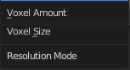
Resolution Mode
Mode for how the voxel size is specified.

Voxel Amount
This allows setting an approximate number of voxels that will be used to represent mesh along its diagonal. When the dimensions of the mesh changes, the voxel size will change as well. For final rendering of animations, it’s better to specify the voxel size explicitly to avoid artifacts.

Voxel Size
This allows setting the exact voxel size that will be used. This is idea for rendering when the voxel size should not change between frames.

Volume - Deform modifiers

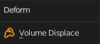

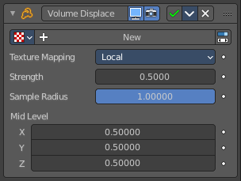
Volume Displace
The Volume Displace modifier displaces existing volume grids by a 3D texture. It uses the RGB color channels of the texture to displace the volume into the X, Y and Z direction.

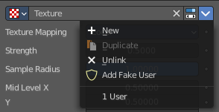
Texture Prop
The texture to use for the displacement of the voxels. For a three dimensional displacement colored textures should be used. Greyscale images just displaces into one direction. Colored images into all three directions.

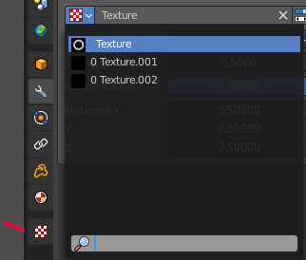
Texture Browser
A list of the available textures in the scene. Textures can be added in the Texture tab in the Properties Editor.

Edit Box
The name of the texture. Here you can also rename the texture.

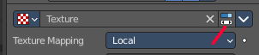
Change Context
Jump to the Texture tab to load a texture.

Unlink
Removes the currently active texture.

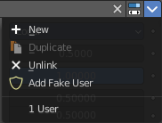
File selector menu

New
Creates a new texture slot. It is blank. You first need to load a texture, which can be done in the Texture tab in the Properties Editor.

Duplicate
Not active in this context.

Unlink
Removes the currently active texture.

Add Fake User
Wit this button you assign a fake user to this selected world.
Data, like worlds, that is not longer linked to anything else gets removed when you save and reload a scene. Bforartists has the concept of fake users to go around this behavior. An image with a fake user is in fact linked to something. And so it is not lost when you save and reload the scene.

User
The number of users that uses this data. Data with a user number of 0 will be removed with closing Bforartists.

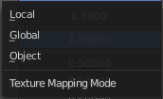
Texture Mapping
What space to use to map the texture onto the object.

Strength
Controls how far voxels are displaced.

Sample Radius
Smaller values result in better performance, but might cut off the volume outside.

Mid Level X Y Z
This should be modified if the texture offsets the entire volume in one direction and you want to center it again. For performance reasons, the displaced volume should stay close to its original position.

